 [Translated from Chinese (Simplified) to English - www.onlinedoctranslator.com](https://www.onlinedoctranslator.com/en/?utm_source=onlinedoctranslator&utm_medium=docx&utm_campaign=attribution)

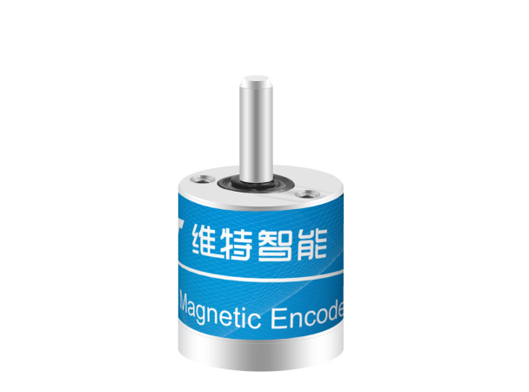JY-ME01 sensor manual

Product specifications:SPECIFICATION

Model: JY-ME01

Description: Angle encoder sensor

Table of contents

1product description

2 Performance parameters

3 pin description

4 Hardware connection methods

4.1 Serial port connection:

4.1.1 With computers

4.1.2 With microcontroller

5 How to use the software

5.1 Connection method

5.2 Mode switching

5.3ASCII mode

5.3.1 AT command set

5.3.2 “AT” command

5.3.4 “AT+UART” command

5.3.5 “AT+ID” command

5.3.6 “AT+PRATE” command

5.3.7 Host computer data recording

5.4Modbus mode

5.4.1Modbus mode description

5.4.2Modbus communication protocol

5.4.3Modbus register address table

5.4.4 Host computer Modbus connection

# productOverview

* Support TTL serial port
* Two modes: serial port mode and Modbus mode.
* Using silicone soft cable, special interface for easy connection
* Small size, wide measurement range, low power consumption, long life, easy to install
* Up to 100Hz data output rate. The output rate is adjustable from 0.1 to 100Hz.
* The module has its own voltage stabilization circuit, and the working voltage is 3.3-5V for easy connection.

# Performance parameters

1. Voltage: 3.3-5V

2. Current: <15mA

3. Volume: 15mm*16mm*3mm*26

4. Data interface:TTLSerial port (baud rate supports 4800-921600 adjustable, 9600 (default))

5,angleMeasuring range:0～360°

6, Resolution: 18 bit

7, Return transmission rate: 0.1~100Hz adjustable.

# Pin description

|  |  |  |
| --- | --- | --- |
| serial number | name | Function |
| 1 | VCC | Module power supply, 3.3V-5Venter |
| 2 | RX | serial data input |
| 3 | Tx | Serial data output |
| 4 | NC | reserve |
| 5 | NC | reserve |
| 6 | GND | Ground wire |

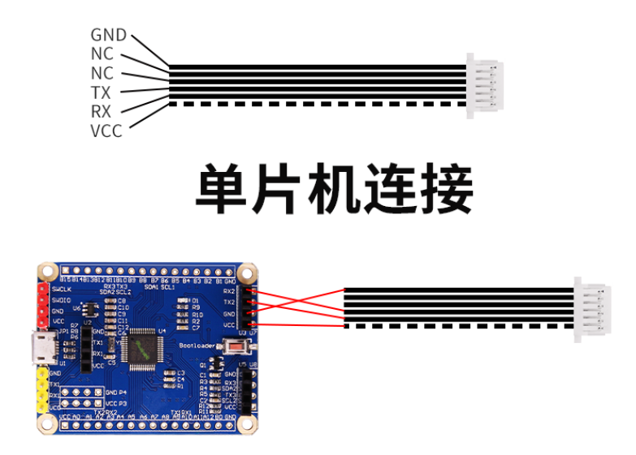

# Hardware connection method

## 4.1 Serial port connection:

### with computer

To connect to the computer, you need to use the development evaluation version as shown in the figure below:

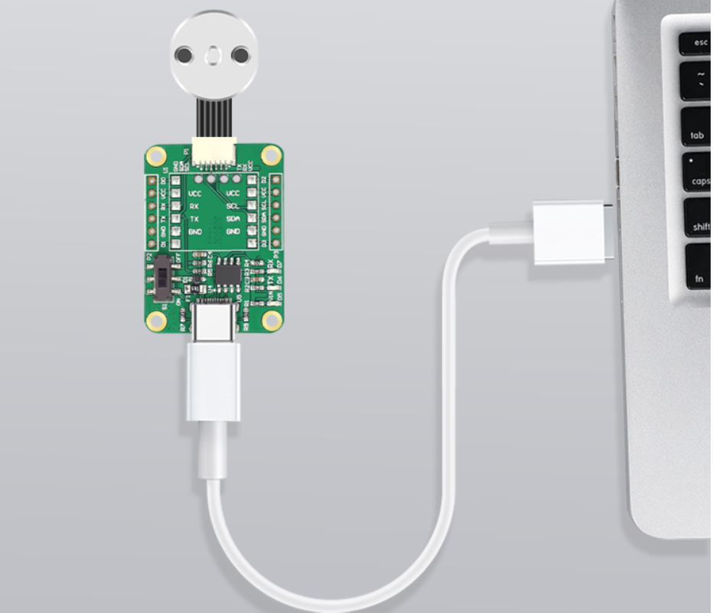

1. Development evaluation board module (Figure 1): The connection method between the module and the development evaluation board is: the VCC TX RX GND of the module is connected to the +5V RX TX GND of the USB serial port module. Connect the module to USB-TTL and plug it into the computer.

The above modules all use CH340 driver

Driver download address:

[https://dl.wit-motion.com/index.html#/wit-service/productLiterature/details?productId=8b6755ba65314ee8a815a15c619593e1](https://dl.wit-motion.com/index.html" \l "/wit-service/productLiterature/details?productId=8b6755ba65314ee8a815a15c619593e1)

### with microcontroller

1. The ones with dotted lines and white dots are the VCC line sequence. Use them according to the pin instructions.

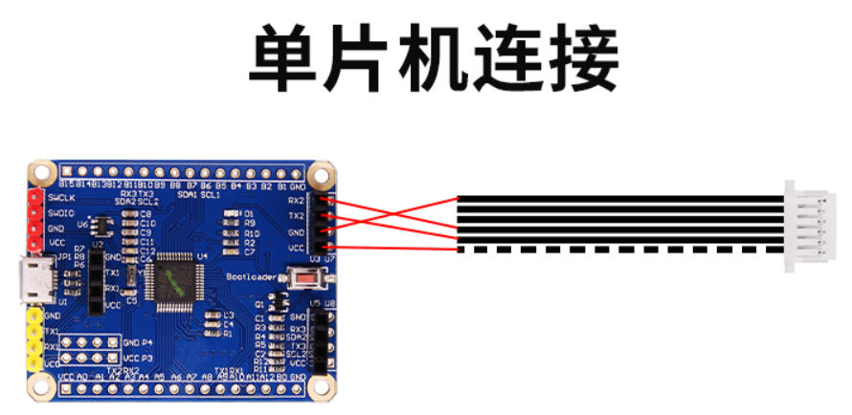

# How to use the software

## 5.1 Connection method

Connect to the computer through the USB to serial port module, and you can query the corresponding port number in the device manager, as shown in the figure:

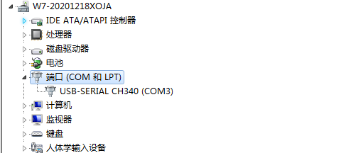

The CH340 and CP2102 driver information links are as follows: [https://pan.baidu.com/s/1S40oR6ls--GEH6Ru2xwFYw#list/path=%2F](https://pan.baidu.com/s/1S40oR6ls--GEH6Ru2xwFYw" \l "list/path=%2F)

Connect the sensor to the computer using USB to TTL. Turn on the host computer, and the host computer will automatically search for the sensor module. If the device cannot be found, please check the hardware connection and click "Add Device". The host computer defaults to ASCII mode. As shown below:



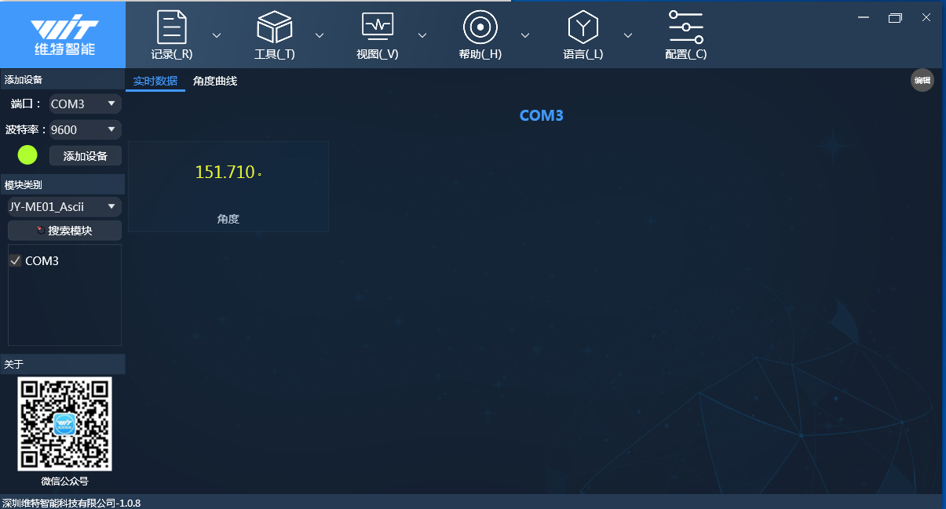

## 5.2 Mode switching

The sensor module has 3 working modes: ASCII mode, Modbus mode, and Modbus active output mode. When using the host computer, you can directly click "Mode" to select. If you need to develop and use it yourself, users can operate and configure it according to the table below.

The method to switch from ASCII mode to Modbus mode is as follows:

|  |  |
| --- | --- |
| model | ASCII mode switch |
| Modbus mode | Switch from ASCII to Modbus mode:  1.Send A from the serial portT+MODE=1Set asModbusmodel  Note: If multiple cascades are required, the sensors need to be set individually to the same baud rate and different IDs. |

Switch Modbus mode to ASCII mode and switch to ModbusThe active output mode method is as follows:

|  |  |
| --- | --- |
| model | Modbus mode switch |
| ASCII mode | Modbus switches to ASCII mode:  1. Send AT+ from the serial portMODE=0Set asASCIImodel  2. Use AT commands to set the return rate.  Example: Set 1Hz return transmission, command: AT+PRATE=1000. |
| ModbusActive output mode | Modbus mode switches toModbusActive output mode:  1. Send AT+ from the serial portMODE=1 is set toModbusmodel  2.UseAT+MRATEThe command sets the modbus return rate.  Example: Set 1Hz backhaul, command: AT+MRATE=1000. |

Modbus active output mode switches to ModbusThe pattern method is as follows:

|  |  |
| --- | --- |
| model | Modbus active output mode switching |
| Modbusmodel | ModbusActive output mode switches to Modbus mode:  1. Send AT+ from the serial portMODE=1 is set toModbusmodel  2.UseAT+MRATECommand settingsMThe odbus return rate is 0.  Example: SettingsModbusThe return rate is 0 command: AT+MRATE=0. |

## 5.3ASCII mode

In ASCII mode, use corresponding AT commands to communicate with the module, which is simple and fast to use. Use USB_TTL to connect the module to the computer, and use the provided host computer or serial port assistant to send AT commands.

Instructions can be sent through the serial port assistant. Manually send the test command "AT" and reply "OK" to indicate successful communication. As shown below:

Note: ASCII mode can only connect one sensor module.

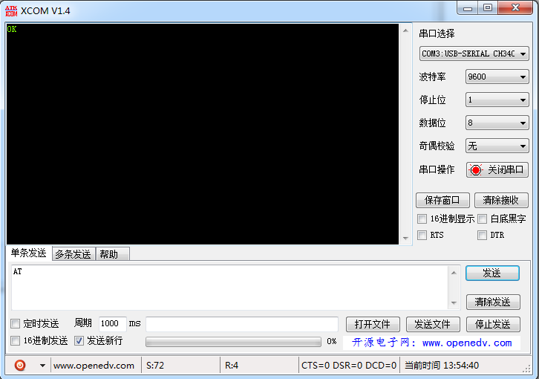

Note: The AT command can only connect to one sensor module. The AT command ends with a newline character (as shown in the picture above: check to add an additional newline character). The "OK" received is in ASCII code format (as shown in the picture above: uncheck the hexadecimal display)

### 5.3.1 AT command set

The following is the AT command list used in ASCII mode. Users can develop their own based on the command list.

|  |  |  |
| --- | --- | --- |
| instruction | Function | Reply content format |
| AT | Check whether the connection is normal | OK |
| AT+UART=1  ...  AT+UART=9 | Change the baud rate to 4800-921600 | OK |
| AT+MODE=? | Query the current mode | +MODE=<MODE> |
| AT+MODE=0 | ASCII mode | OK |
| AT+MODE=1 | Modbus mode | OK |
| AT+ID=? | Query module ID (0-254) | +ID=<ID> |
| AT+ID=<0-254 number> | Change Modbus address | OK |
| AT+PRATE=0 | Set to single postback mode | OK  Yaw:<Angle of z-axis> |
| AT+PRATE=<10-10000> | Set the return speed unit ms | OK  Yaw:<Angle of z-axis> |
| AT+MRATE=? | Query the current Modbus rate | +MRATE=<MRATE> |
| AT+MRATE=0 | Set to standard Modbus, one question and one answer | OK |
| AT+MRATE=<10-10000> | Once this register is set to a non-0 state, it enters the active output Modbus mode, that is, non-standard Modbus | OK |
|  | Wrong instruction | ERROR |

Note: All AT commands end with a carriage return and line feed ("Additional line feed" must be checked)

### 5.3.2 “AT” command

The "AT" command is to check whether the hardware connection is normal. Enter "AT" in the send field (check "Add additional line breaks") and click send. If the reply is "OK", it means the communication is normal, otherwise it means the communication is abnormal. The serial port assistant demonstration is as follows:



### 5.3.4 “AT+UART” command

The "AT+UART" command is to change the serial port baud rate. After checking that the communication is normal, you can click the change baud rate button below, or manually send the command "AT+UART=1" (baud rate 4800), "AT+UART=2" (baud rate 9600), "AT+ UART=3" (baud rate 19200), click Send. If the reply is "OK", the change is successful.

Note: After changing the baud rate, you need to manually change the baud rate of the host computer, or click on the automatic search device to reset the baud rate of the host computer.

The figure below shows changing the baud rate9600, the baud rate needs to be set manually.

Serial Assistant Demonstration

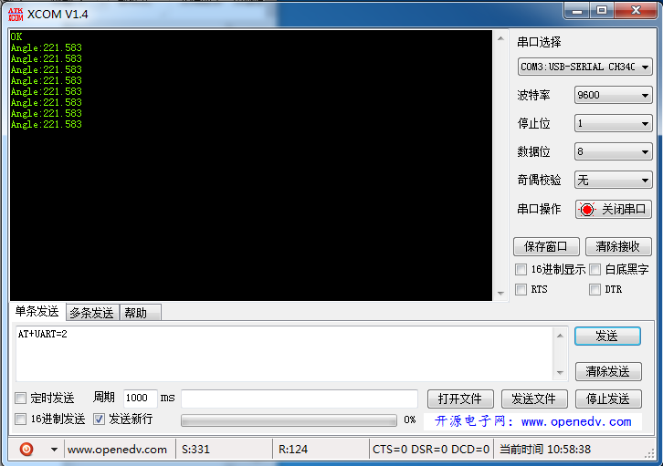

### 5.3.5 “AT+ID” command

The "AT+ID" command is to change the Modbus address of the query module. After checking that the communication is normal, click "Query ID", or enter "AT+ID=?" in the send field and click send. You can query the module ID.

Example: Reply "+ID=0", indicating that the current module address is "0". For example, send "AT+ID=1" to change the module ID to 1, and reply "OK" to indicate that the change is successful. The address can be changed to 0-254, which is 0x00-0xFE. The specific operation is as shown below (the default address is: 0x00):

Serial Assistant Demonstration

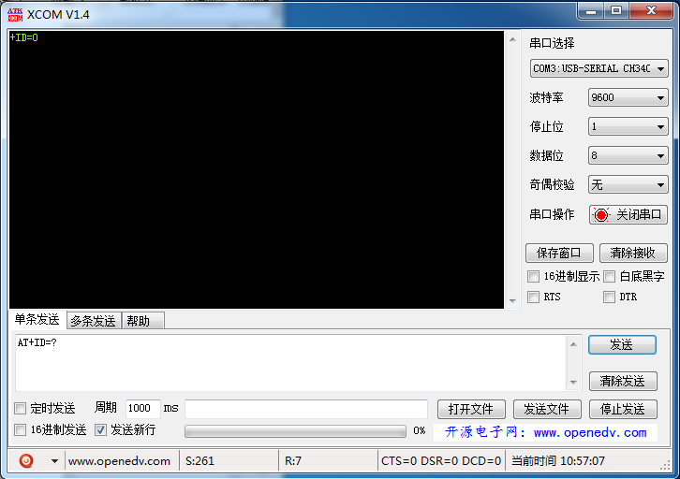

### 5.3.6 “AT+PRATE” command

The "AT+PRATE" command is to change the module return speed. You can manually send the corresponding command and set "AT+PRATE=0" to set it as a single return, that is, send it once and return it once. "AT+PRATE=1000" sets the custom return time to 1000, in milliseconds, that is, the return rate is 1Hz, which can be set to 10-10000 (0.10 seconds to 10 seconds). The module needs to be initialized before querying the acceleration. If it is rejected, the correct acceleration data will not be collected (if it is set to automatically transmit back, it will automatically initialize and transmit back the acceleration data next time it is powered on). The specific operation is as follows:

Serial Assistant Demonstration

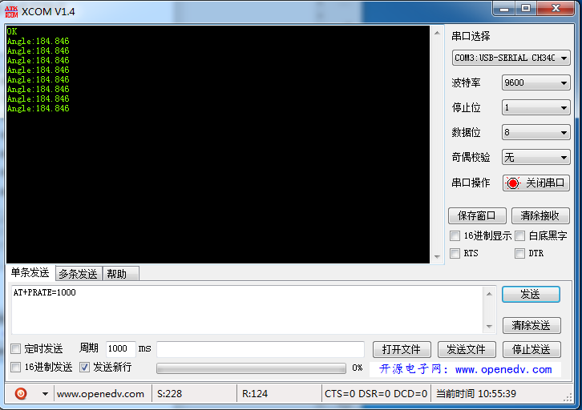

### 5.3.6 “AT+MRATE” command

The "AT+MRATE" command is to change the return speed of the module in modbus mode. You can manually send the corresponding command and set "AT+PRATE=0" to set it as a single return, that is, send it once and return it once. "AT+MRATE=1000" sets the custom return time to 1000, in milliseconds, that is, the return rate is 1Hz, which can be set from 10 to 10000 (0.10 seconds to 10 seconds). The module needs to be initialized before querying the acceleration. If it is rejected, the correct acceleration data will not be collected (if it is set to automatically transmit back the next time it is powered on, it will automatically initialize and transmit the acceleration data back. Note that this state is non-standard modbus communication)

### 5.3.7 Host computer data recording

The host computer has a data recording function in ASCII mode, and can save the sensor output data as a TXT file to facilitate data storage for data analysis.

How to save data, for example, set the sensor to 1Hz automatic return, click "Start Recording".

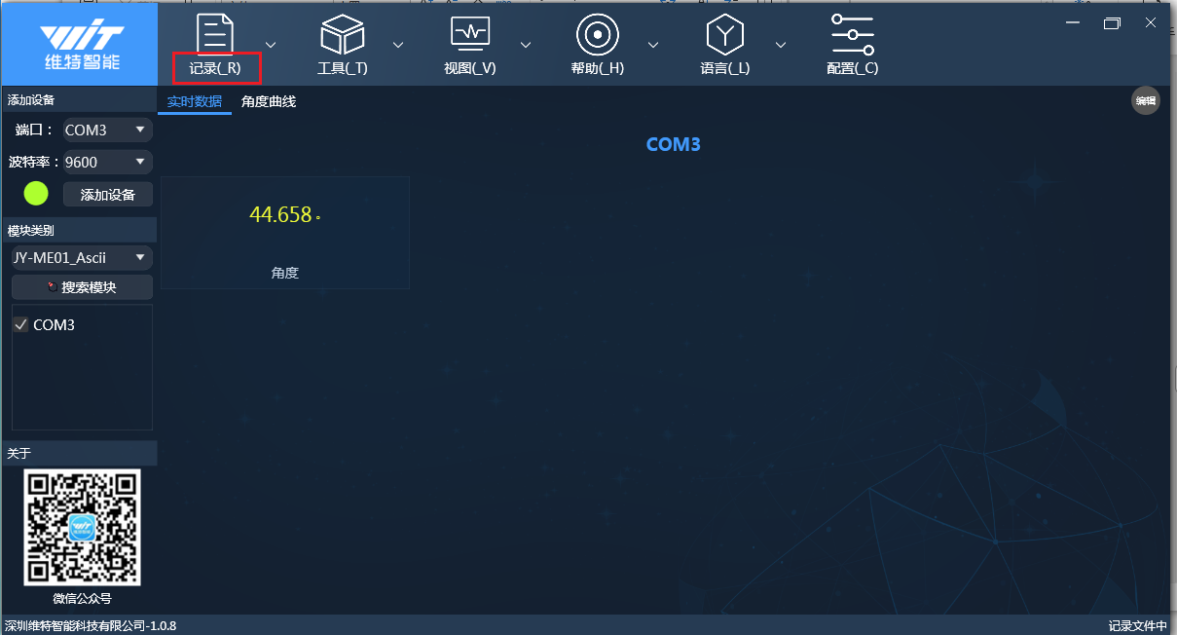

After clicking "End Recording", a popup will pop up whether to open the recording file. As shown below:

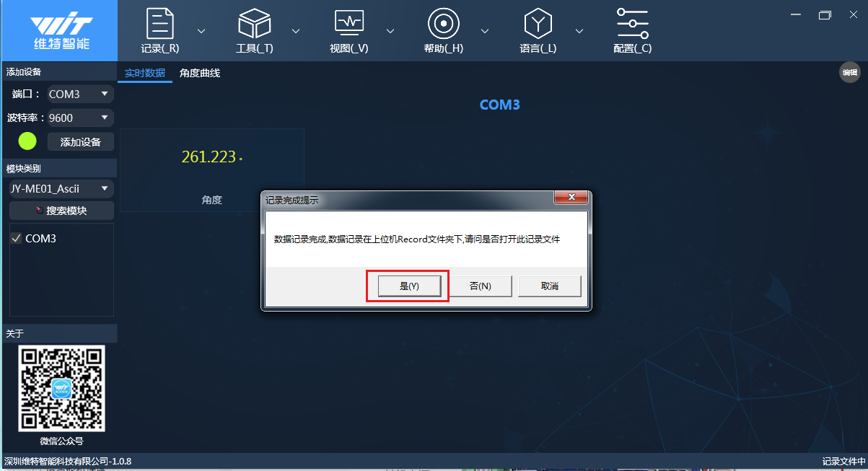

After the recording is completed, you can click "End Recording" and a pop-up window will prompt whether to open the recording file. The record file can also be found in the DATA folder in the root directory of the host computer. The record file is as shown below:

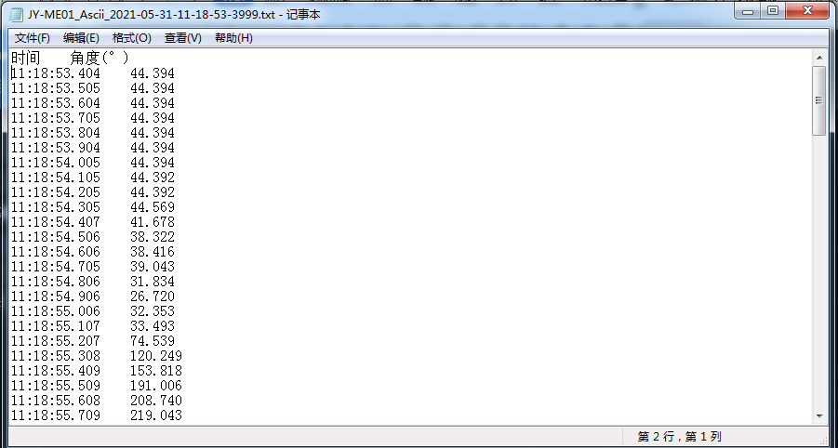

## 5.4Modbus mode

### 5.4.1Modbus mode description

Modbus mode, use Modbus protocol to collect data and use ModbusThe operation of the mode is as follows

1Send command A from the serial portT+MODE=1Set to Modbusmodel

2Access the register address to obtain data. Please refer to Section 5.4.3 for the register address table.

### 5.4.2Modbus communication protocol

Modbus communication, the command number is divided into two types: read command and write command. 0x03 (read command) reads the corresponding register data, and 0x06 (write command) writes data to the corresponding register.

Host computer sends data frame

|  |  |  |  |  |  |  |  |
| --- | --- | --- | --- | --- | --- | --- | --- |
| ID | Order number | Register address high bit | Register address low bit | Read length high bit | Read length low bit | CRC check high bit | CRC check low bit |
| ID | CMD | RH | RegL | L | LenL | CRCH | CRCL |

Example: module address is 0x00, read command 0x03, register 0XD4 (device id), one-digit length.

instruction:00 03 00 D4 00 01 C5 E3

module reply frame

|  |  |  |  |  |  |  |  |
| --- | --- | --- | --- | --- | --- | --- | --- |
| ID | Order number | Data length | Data bit 1 | Data bit 2 |  | CRC check high bit | CRC check low bit |
| ID | CMD | L | DataH | DataL | ..... | CRCH | CRCL |

Example: The module address is 0x00, the read command is 0x03, and the length is 2 bits. replied as below

Command: 00 03 02 00 00 85 84

The instruction is read as shown below:

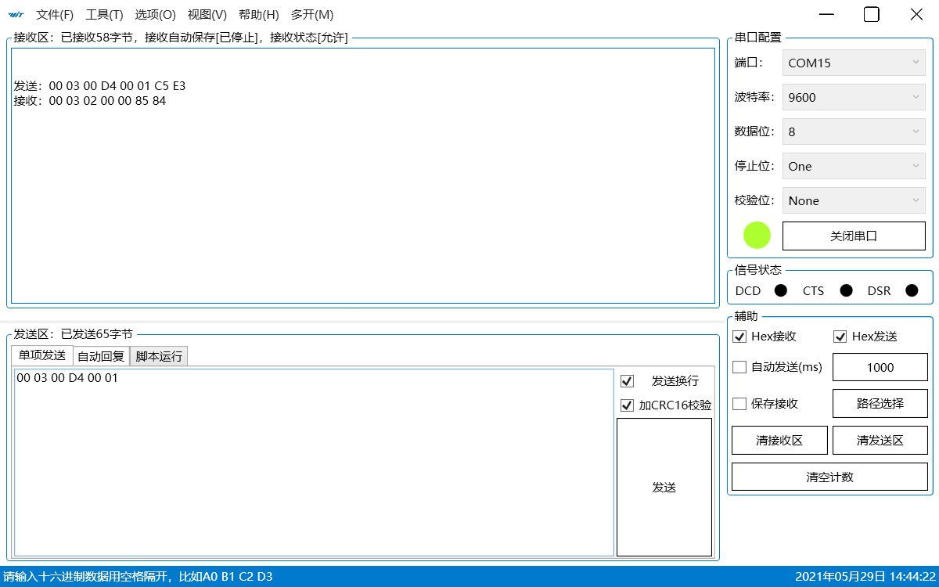

### 5.4.3Modbus register address table

|  |  |  |  |
| --- | --- | --- | --- |
| Register name | Register address | access operation | Sending format and example (example is access address: 0x00) |
| VERSION (version number) | 0xD0 | read | Send: 00 03 00 D0 00 01 CRCH CRCL (single read)  Return: 00 03 02 34 C1 CRCH CRCL (0x34C1 = 13505) |
| MODE(mode) | 0xD1 | read/write | Send: 00 06 00 D1 00 00 CRCH CRCL  Return: 00 06 00 D1 00 00 CRCH CRCL  (Change the return mode to asc) |
| BAUD (baud rate)  value  2:9600  3:115200  9:921600 | 0xD2 | read/write | Send: 00 03 00 D2 00 01 CRCH CRCL (read baud rate)  Send: 00 06 00 D2 00 02 CRCH CRCL (0: 9600 default)  Send: 00 06 00 D2 00 03 CRCH CRCL (1:115200)  Send: 00 06 00 D2 00 09 CRCH CRCL (2: 921600) |
| PRATE (return rate)  Value:  1-10000: (unit ms/time)  0:Single return | 0xD3 | read/write | Send: 00 03 00 D3 00 01 CRCH CRCL (read return rate)  Send: 00 06 00 D3 00 00 CRCH CRCL (0: single)  Send: 00 06 00 D3 00 0A CRCH CRCL (10: 100Hz)  Send: 00 06 00 D3 00 64 CRCH CRCL (100: 10Hz) |
| ID (device ID)  Value:  0-254 | 0xD4 | read/write | Send: 00 03 00 D4 00 01 CRCH CRCL (read ID)  Send: 00 06 00 D4 00 50 CRCH CRCL (ID modified to 0x50) |
| ANGH (angle high register) | 0xD5 | read only | Send: 00 03 00 D5 00 01 CRCH CRCL (read angle high register)  Send: 00 03 02 00 00 CRCH CRCL  Angle calculation formula: [ANGH<<16|ANGL]/262144*360 |
| ANGL (angle low register) | 0xD6 | read only | Send: 00 03 00 D6 00 01 CRCH CRCL (read angle low register)  Receive: 00 03 02 4E 48 CRCH CRCL  Angle calculation formula: [ANGH<<16|ANGL]/262144*360 |
| MRATE (unsolicited return interval) Value: 0~1000 0: No active output Others: interval time ms | 0xD7 | read/write | Send: 00 06 00 D700 00 CRCH CRCL (0: Standard Modbus) Send: 00 06 00 D700 0A CRCH CRCL (10: interval 10ms) Send: 00 06 00 D700 64 CRCH CRCL (100: interval 100ms) |

Angle calculation formula: [ANGH<<16|ANGL]/262144*360

### 5.4.4 Host computer Modbus connection

After connecting to the computer, turn on the host computer and enter the configuration to select Modbus mode. Select the baud rate, port number, and ID and then add the device to connect the device.

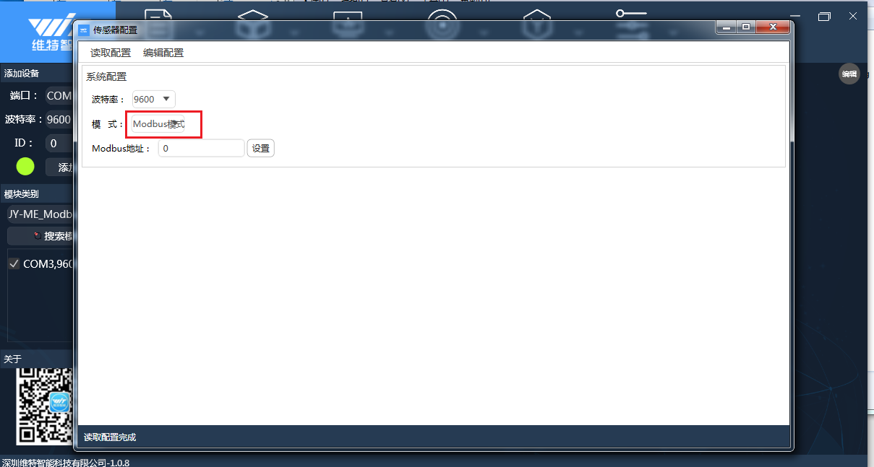

5.4.5 Automatic return Modbus mode

The module has an automatic return Modbus mode. In the automatic return Modbus mode, the heading angle data will be actively returned. Use the method of automatic return Modbus mode.

1Send the command AT+MODE=1 to enter Modbus mode

2Send the command AT+MRATE=numeric value to adjust the Modbus mode return rate

**In this mode, Modbus commands are sent back, so you need to use hexadecimal to view the data.**

Serial port assistant example

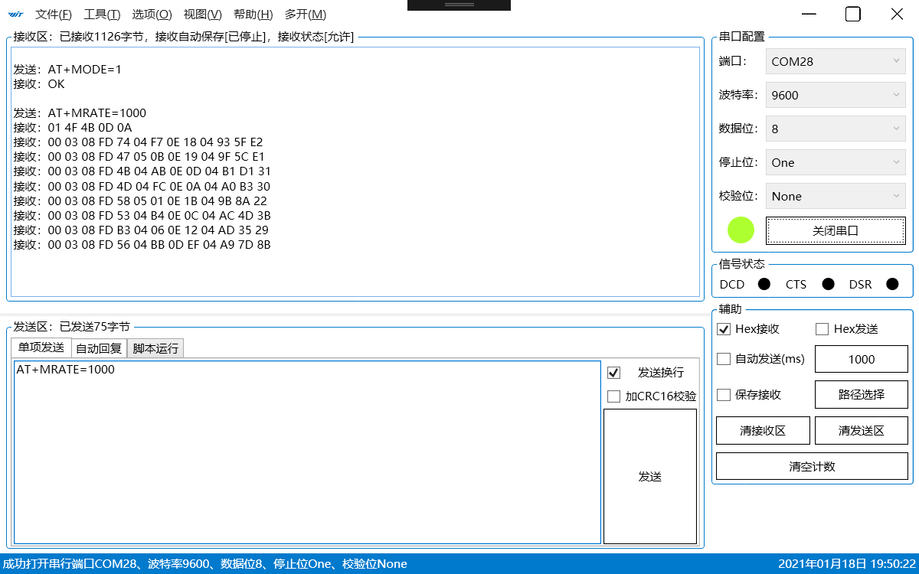

For example:00 03 04 00 01 5F CF C2 97

Original data: 00015FCF (hexadecimal) 90063 (decimal)

Angle data: Angle = 90063 / 262144 * 360 = 123.682708



Shenzhen Weite Intelligent Technology Co., Ltd.

WitMotion ShenZhen Co., Ltd

Telephone:0755-33185882

Email: wit@wit-motion.com

website:www.wit-motion.com

Shop: https://robotcontrol.taobao.com

Address: Honghai Building, Star Home, Songgang Town, Baoan District, Shenzhen City, Guangdong Province